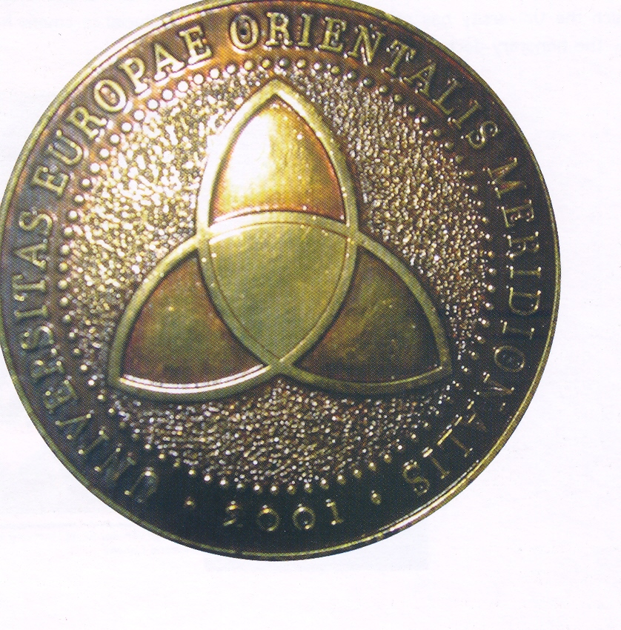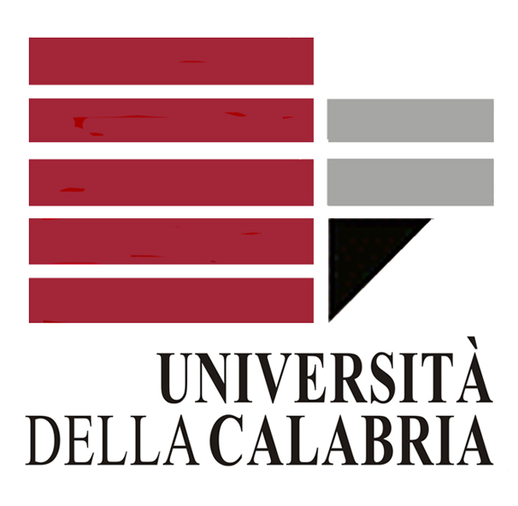

VENERDI’ 22 MAGGIO 2009 FIRMA DI UN ACCORDO DI COOPERAZIONE SCIENTIFICA E DIDATTICA TRA L’UNIVERSITÀ DELLA CALABRIA E L’UNIVERSITÀ DEL SUD-EST EUROPEO DI TETOVO (REPUBBLICA DI MACEDONIA)

Tra l’Università della Calabria e l’Università del Sud-est europeo di Tetovo verrà firmato venerdì 22 maggio 2009, alle ore 17, nel corso di una cerimonia che si terrà presso la Sala Stampa dell’Aula Magna dell’Ateneo calabrese, un importante accordo quadro di cooperazione multilaterale. Si tratta del primo accordo ufficiale che viene sottoscritto dall’Università del Sud-est europeo di Tetovo con una Università italiana, dopo che la stessa ha già firmato accordi bilaterali di collaborazione con due Università britanniche, due Università austriache, tre Università francesi, una Università svizzera e due Università degli USA.
Esso riguarda oltre all’albanistica e alla balcanistica, tutti gli ambiti didattici e scientifici di interesse reciproco e mira a creare un rapporto di stretta collaborazione tra i due Atenei, accomunati, tra l’altro, oltre che dal modello organizzativo del campus, anche dallo stesso obiettivo di puntare con la qualità della loro formazione e delle loro ricerche allo sviluppo socio-economico e tecnologico delle rispettive aree regionali di riferimento.
L’accordo di cooperazione verrà sottoscritto dai Rettori dei due Atenei: il prof. Alajdin Abazi, Rettore dell’Università del Sud-est europeo di Tetovo, e il prof. Giovanni Latorre, Rettore dell’Università della Calabria.
Alla cerimonia interverranno anche una folta delegazione di docenti e studenti dell’Università macedone, i quali da ormai tre anni partecipano a periodiche visite di studio e di ricerca presso l’Ateneo calabrese e nelle comunità albanesi della nostra regione, nonché una delegazione di docenti e studenti del Master per operatori linguistici e culturali di area arbëreshe organizzato dalla Facoltà di Lettere e Filosofia dell’Ateneo di Arcavacata.
L’iniziativa della firma di questo accordo è partita congiuntamente dai direttori dei Dipartimenti di Linguistica dei due Atenei - il prof. Francesco Altimari, per l’Università della Calabria, e il prof. Hamid Xhaferi, per l’Università del Sud-est europeo di Tetovo – partendo dalla comune e avanzata esperienza didattica e scientifica maturata dai due Atenei nel campo degli studi di albanistica e di balcanistica.

L’Università del Sud-Est Europeo di Tetovo (Repubblica di Macedonia)

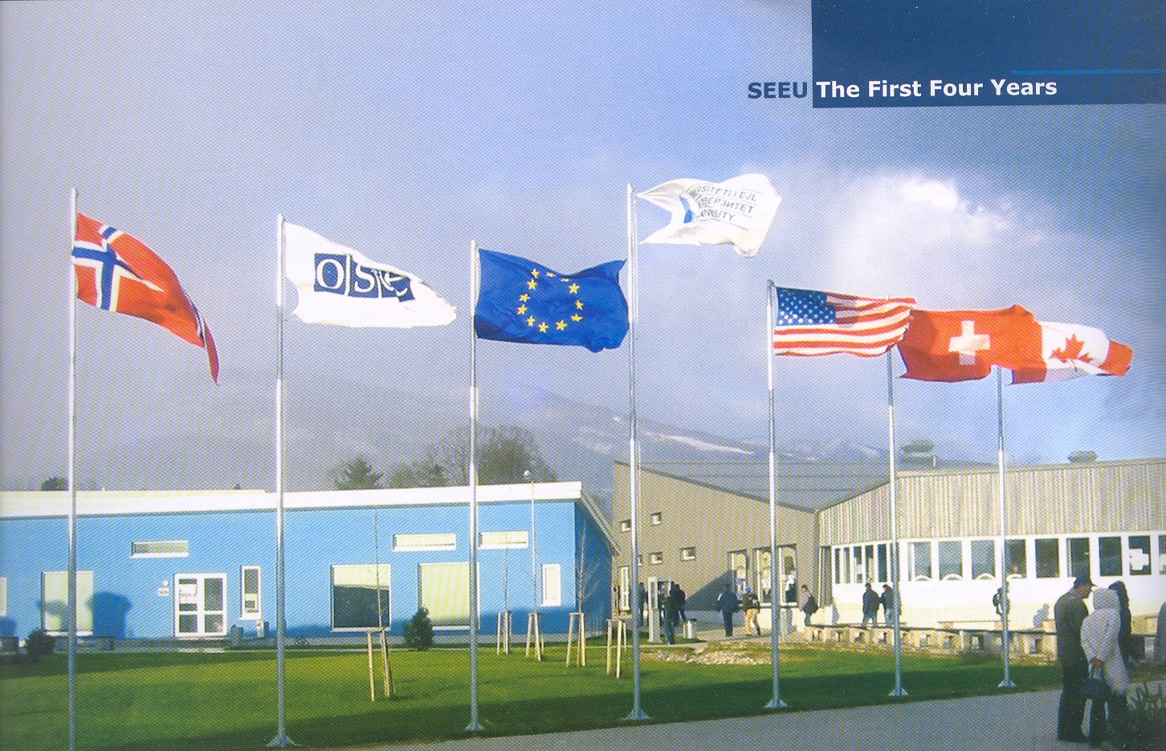

L’Ateneo del Sud-Est Europeo di Tetovo, città albanese della Repubblica di Macedonia, è stato fondato nel 2000 e oggi conta più di 7000 studenti e 3000 laureati. Sin dalla sua fondazione esso si è caratterizzato e qualificato come Ateneo leader dell’area, con una solida stabilità finanziaria ed è stato preso come modello d’istruzione universitaria multietnico e plurilingue nell’Europa sud-orientale: i corsi si tengono in questo Ateneo in tre lingue ufficiali (inglese, macedone e albanese).

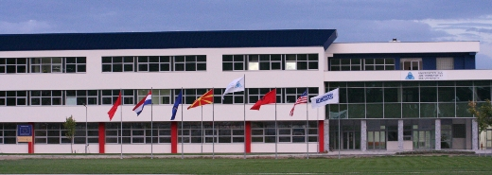

Questa Università continua oggi le sue attività usufruendo della costante collaborazione accademica che le viene fornita dalla Commissione dell’Unione Europea, dagli USA e dai Paesi Bassi, che assieme ad altri donatori internazionali assicurano il suo sviluppo, che ha assunto in pochi anni ritmi davvero elevati, non solo per l’area geografica in cui è collocata.

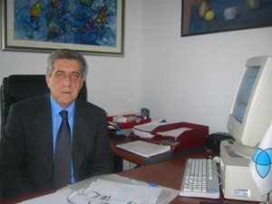

Tra gli obbiettivi principali di questo Ateneo, guidato sin dalla sua fondazione dal prof. dr. Alajdin Abazi (nella foto), ingegnere elettronico, membro dal 2006 anche dell’Accademia delle Arti e delle Scienze di Macedonia, riveste un ruolo primario e strategico l’internazionalizzazione dei percorsi formativi e della ricerca, che viene concretamente favorita dalla promozione di scambi di esperienze con altri Atenei esteri che coinvolgono studenti, personale docente e personale tecnico-amministrativo.
Attualmente quest’ateneo è associato a diversi network internazionali come:

- European University Association
- Francophone Association of Universities
- The Network of Universities in South East Europe
- Central European Initiative Network
- Academic Training Association
L’Università del SEE di Tetovo comprende oggi cinque facoltà di cui offre una formazione completa secondo l’ordinamento universitario di Bologna.
Esse sono:

- Faculty of Law
-

Faculty of Business Administration
-

Public Administration and Political Sciences
-

Faculty of Contemporary Sciences and Technologies
-

Faculty of Languages, Cultures and Comunications

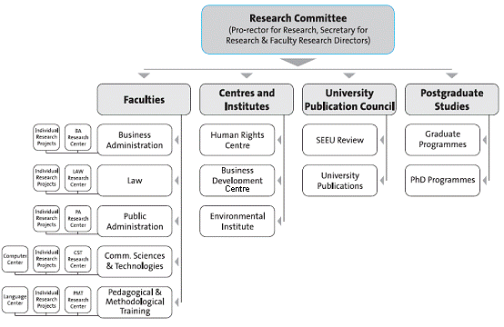

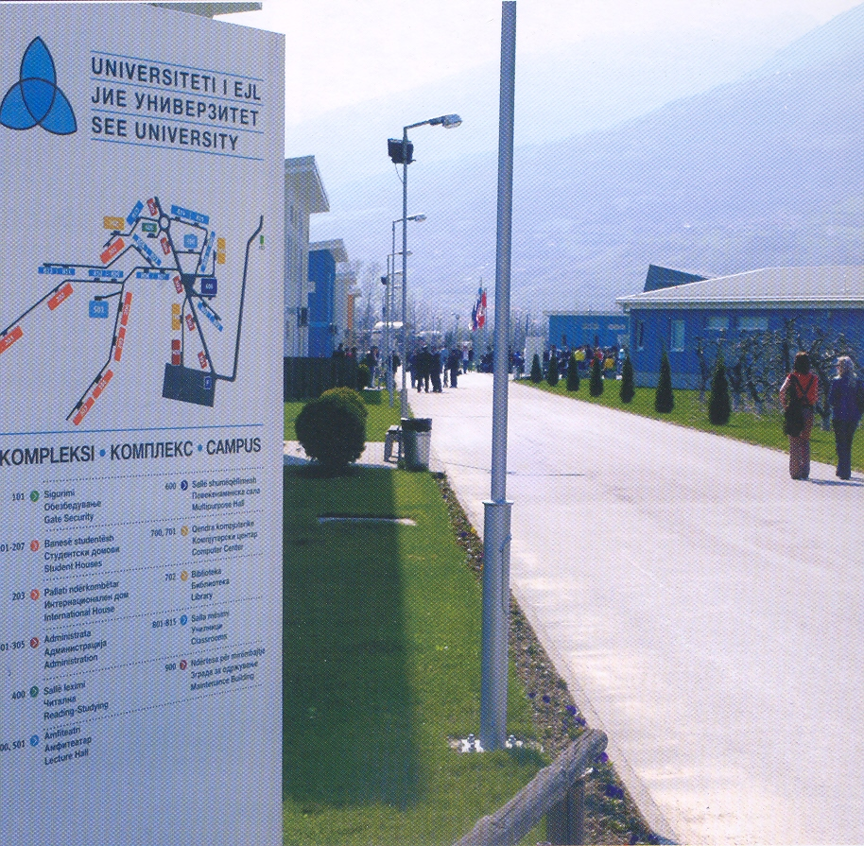

SOUTH EAST EUROPEAN UNIVERSITY OF TETOVO (MACEDONIA)

SEEU is now in its eighth year of operation with more than 7000 students and 3000 graduates. From opening its campus in Tetovo in October 2001 it has succeeded in establishing itself as a quality-led, financially sustainable university now regarded as a model for multi-ethnic, multi-lingual higher education in South East Europe. Moreover, it has succeeded in combining the best of European and US experience, continuing to benefit from academic collaborations sponsored by the EU Commission and USAID among other donors. It benefits from scholarship supported provided by The Netherlands and The Open Society Institute. Its history, which you can read in 'About the University' is a fascinating account of how SEEU has reached this position of strength against a background of political and economic uncertainties in the region. Now SEEU reaches out both to other institutions in promoting research collaboration, exchange of students and staff and also to its community. Globalisation is rapidly bringing the world closer together, and today students need international experience to be prepared for tomorrow's workplace. Internationalisation of curricula and opportunities for mobility are now important responsibilities for universities, and the Research and International Relations Office at South East European University is dedicated to developing and promoting a variety of international educational opportunities for students as well as for teaching and administrative staff.
The Research and International Relations Office (International Office), aims to improve the quality of education and research through internationalisation. The services it offers aim to complement and facilitate management, education, research and to assist student and staff mobility.
The University has so far been incorporated in different networks such as:
- European University Association
- Francophone Association of Universities
- The Network of Universities in South East Europe
- Central European Initiative Network
- Academic Training Association

Quality assurance at SEEU
It is the intention of SEE University to comply with best European practice in quality assessment, evaluation, and accountability. The University is developing its curricula, programmes, and quality assurance mechanisms to ensure maximum compatibility with the development of the European Higher Education Area as foreseen among others in the Bologna Declaration.
SEEU is participating in a European University Association Quality Culture III project and keeps continually in touch with developments within the European Network for Quality Assurance, and other bodies.
From its establishment, SEEU has introduced the European Credit Transfer System (ECTS) throughout which we are facing all the challenges that this system brings within terms of Quality management. SEEU has already implemented successfully Evaluation models such as Student evaluation and staff evaluation. In 2004/2005 the overall participation of the students in the process of evaluation increased to 40% and it is becoming a real mechanism in building the quality culture and strengthening SEEU community identity.
SEEU is an institution offering study programmes at both undergraduate level and postgraduate level across five disciplines. This link presents the academic departments of SEEU and provides detailed information about the different study programmes offered.
- Faculty of Law
-

Faculty of Business Administration
-

Public Administration and Political Sciences
-

Faculty of Contemporary Sciences and Technologies
-

Faculty of Languages, Cultures and Comunications

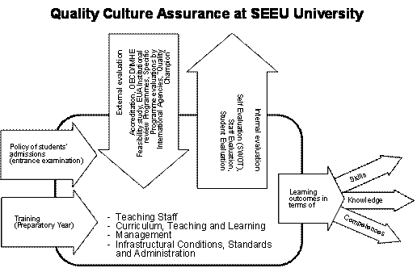

A coherent, long-term strategy of quality assurance is already on the place. SEEU has answered structurally to this challenge strongly recommended by the Bologna Declaration and have already appointed an external part-time expert (‘Quality Champion’), who is working on continuous quality improvement with the assistance of a University level Quality Assurance Commission, and Faculty Commissions including stakeholder representatives.

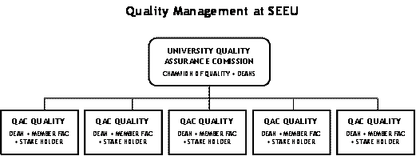

External evaluation as an instrument for objective definition of the strength and weaknesses, opportunities and threats at the University has already taken place at the University. The European University Association (EUA) Review Team has produced an evaluation report for SEEU with recommendations that are helping the University to permanently improve the quality towards standards that are exceeding our regional boundaries.

LIBRARY„Max van der Stoel“
The “Max van der Stoel” library is an institutional library serving scholarly research and educational purposes at the South East European University. The library is conveniently located in building 702 on campus and it is named after our first honorary Doctorate recipient, the former OSCE High Commissioner for National Minorities, Mr. Max van der Stoel. It is his vision which the University has realized and now carries on. The library is open only to SEEU students and staff.
The library's principal obligation is to stock literature and other materials within the social sciences, culture and communication. The collection includes more than 11.350 titles and over 26.000 books in total, in addition to a wide number of journals, international reports, CD-ROMs, local and international newspapers, and other periodicals. The collection is arranged after the Dewey decimal classification.
Information about book titles can also be found online at our online catalogue.
The Library is open all weekdays from 08.00 – 23.00 and Saturdays from 10.00 – 14.00, during which students have access not only to the library collection, but also computers with internet access and reading rooms that meet the requirements and needs of any student.
The SEE University has managed to establish close ties, and signed Bilateral Agreements, at University level, with two Universities from the United Kingdom, two Universities from Austria, three from France, one from Switzerland and two from the United States.
TESTO DELL’ACCORDO:

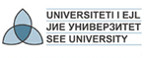
Agreement on Co-operation
between
the South East European University
and
Università della Calabria

The South East European University (Republic of Macedonia) and Università della Calabria also known as the University of Cosenza (Università di Cosenza), hereinto referred as the University of Calabria (Republic of Italy), hereby agree to stimulate and mutually support a co-operative relationship, which will emphasise the development of collaborative educational and research projects. Both universities will encourage direct contact and co-operation between their faculty members, departments, institutes and other research centres subject to the provisions of this Agreement.

1.

Within the fields of study to be mutually designated, the South East European University and the University of Calabria agree to the following general forms of co-operation:

- The exchange of academic staff
- The exchange of administrative and professional staff
- The exchange of students in all three cycles of study
- Joint organization of courses, study tours, conferences and seminars
- Capacity building of both higher education institutions via partnership agreements for the organisation of second cycle (Master Study Programmes) and third cycle (Doctoral Study Programmes). Moreover, capacity building in further curricula development and other academic related activities
- Joint research projects, including applications for governmental and foundation funding. Moreover, broad cooperation in different research and didactical fields in the common interest of both Universities.
- Joint cooperation between specific Faculty level cooperation such as the Faculty of Languages, Cultures, and Communications at the South East European University and similar Faculty at the University of Calabria
- Other forms of university co-operation of mutual interest.

2.

Each university will name a liaison person who will be responsible for co-ordinating activities related to this Agreement. On behalf of the South East European University, the International Relations Office along with one representative of a specific Faculty shall be the co-ordinating body. On behalf of the University of Calabria, a coordinating body shall be chosen in a timely fashion.
3.
Terms of joint activities, the conditions for utilising the results achieved, and arrangements for specific visits, exchanges and other forms of co-operation will be negotiated for each specific activity. It is also understood that any financial arrangements will be negotiated and agreed to in writing for each specific case and will depend upon the availability of funds.
Travel expenses for the academic and research staff will be covered by the sending university; living expenses (accommodation and per diem) by the receiving university.

4.

Exchange of academic staff, research scientists, yearly quotas, duration of their stay will be defined in a separately prepared working programme. This working programme can be rearranged every three years in accordance of the proposals of the parties to meet the new demands and requirements.
5.

The student exchange will be regulated by the special agreement and/or the working programme between the institutions.
6.

The universities stated that the medical insurance expenses during the stay will be covered by participants in the exchange programme.

7.

This Agreement will become effective upon the date of signature by the representatives of the two universities. This Agreement shall begin on 1 January 2009 and shall be valid for a period of three years. After expiration, both Universities shall come to agreement to extend the Agreement for another three year period.

Amendments may be incorporated with the mutual written consent of both universities. Procedurally, this will be done by adding annexes to this Agreement in which both Universities shall come to agreement. The representative of either university may terminate the Agreement by written notice at least six months before its date of expiry. Such termination shall not affect the rights of anybody exchanged under this Agreement prior to receipt of such notice.

Date:

_____________________________ _____________________________

Academician Prof. Alajdin Abazi Prof. Giovanni Latorre
Rector Rector
South East European University University of Calabria

